**ASSIGNMENT-1**

SMART HOME APPLIANCE FOR SMOKE DETECTOR

Components:

1. Ardiuno Uno R3
2. LED
3. Gas Sensor
4. Piezoelectric Speaker

Circuit Diagram:

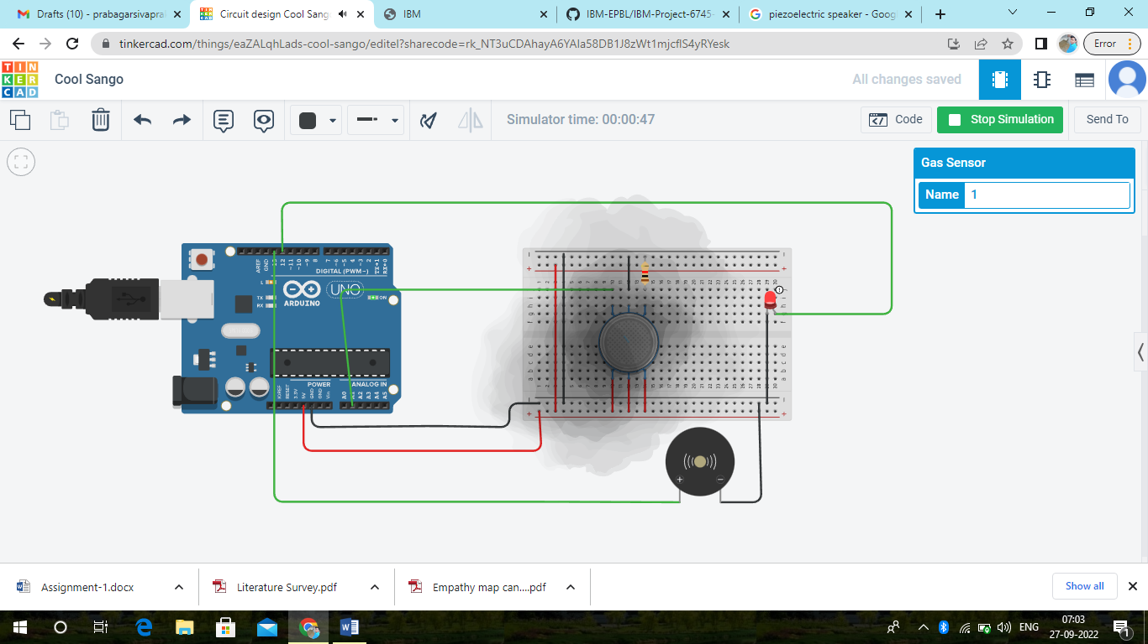

This Circuit will be used to detect the smoke(fire) inside the house. When the smoke level increases above 250 the LED will Turn ON and the Piezoelectric Speaker will alarm. When the smoke level less than 250 the LED will Turn OFF and the Piezoelectric Speaker will be OFF.

PROGRAM:

int gasSensor=A1;

int buzzer=13;

int led=12;

void setup()

{

pinMode(A1,INPUT);

pinMode(buzzer, OUTPUT);

pinMode(led, OUTPUT);

Serial.begin(9600);

}

void loop()

{

int sensorValue=analogRead(gasSensor);

Serial.print("GAS LEVEL:");

Serial.println(sensorValue);

delay(1000);

if (sensorValue>250)

{

digitalWrite(buzzer,HIGH);

digitalWrite(led,HIGH);

}

else

{

digitalWrite(buzzer, LOW);

digitalWrite(led, LOW);

}

}